***Software Engineering LAB7***

Jana Abi Farraj 202304581

Rani bou ghannam 202306058

Abdallah Al Markabawi 202202313

Mohammad Mansour 202300908

EXERCISE 1

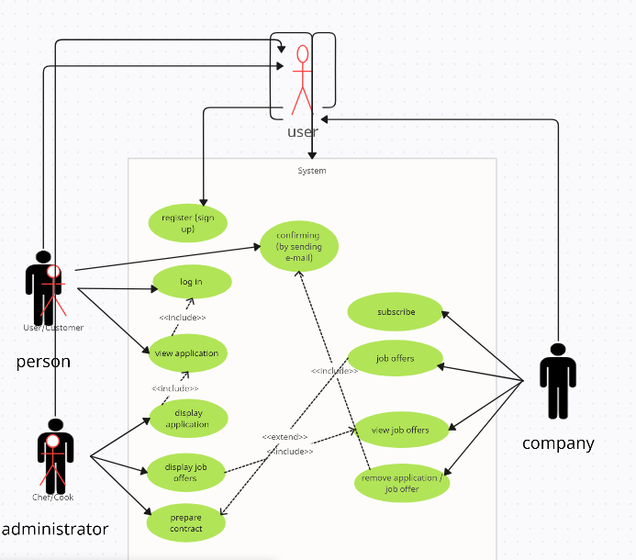

|  |  |
| --- | --- |
| Use Case Name | Person Registration |
| Actors | Person Seeking Employment |
| Goal | Allow persons seeking employment to register and create profiles on the employment company's website. |
| Preconditions | The person has personal information ready to fill out the registration form |
| Summary | The person seeking employment fills out a registration form on the website, providing the necessary personal information to create a profile. |
| Steps |  |
| Actor Action | 1.Access Registration Page: The person seeking employment navigates to the registration page on the employment company's website.  2.Fill out Registration Form: The person enters their personal information into the registration form.  3.Submit Registration Form: After completing the form, the person submits it through the website interface. |
| System Action | 4. Generate Registration Code: The system processes the submitted information and generates a unique registration code for the person. |
| Postconditions | The person has successfully registered on the employment company's website. |

EXERCISE 2

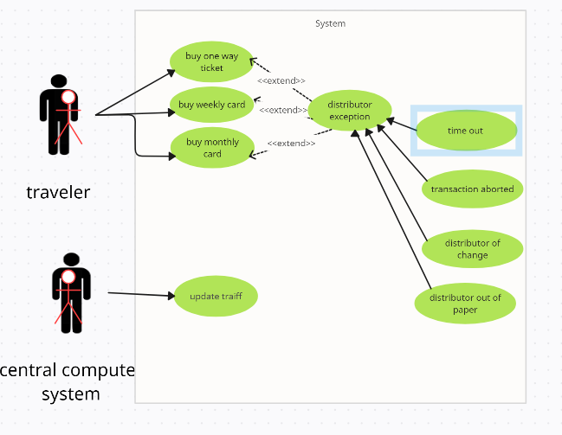

|  |  |
| --- | --- |
| Use case | Purchase One-Way Ticket |
| Actor | * Traveler * Central Computer System |
| Goals | Allow the traveler to purchase a one-way ticket. |
| Preconditions | * The ticket distributor is operational * The traveler is present at the ticket distributor |
| Summary | The traveler purchases a one-way ticket from the ticket distributor. |
| Related use case | * Buy weekly card * Buy monthly card * Update tariff |
| Steps |  |
| Actor action | System actions |
| 1. The system validates the inserted money.  2. The system updates the ticket database to reflect the purchase of the one-way ticket.  3. the system dispenses the one-way ticket.  4. The system confirms the transaction. | * the system validates the inserted money. * the system updates the ticket database to reflect the purchase of the one-way ticket. * the system dispenses the one-way ticket * The system confirms the transaction. |
| Post conditions | * The traveler possesses a valid one-way ticket. * The ticket distributor is ready for the next transaction. |

EXERCISE 3

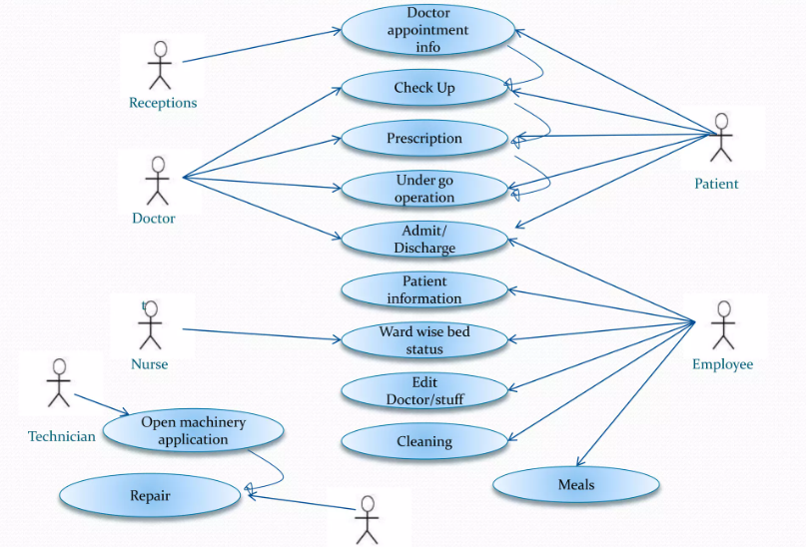

|  |  |
| --- | --- |
| Use case | View application |
| Actor | User |
| Goals | It is the ability to use the app |
| Preconditions | The users has access to the app/website |
| Summary | The users access the features and option of the application |
| Related use case | Includes: log inn to the website/app  Includes: accessing the records or history  Includes: booking an appointment  Includes: checking on the hospital and its location, terms of service and others features |
| Steps |  |
| Actor action | System actions |
| 1. The users opens the website/ application and gets promoted to log in or sign up to the account.  4. the user then can proceed to access or click on whatever uses he is looking for. | 2. the system reads the users and save its profile for later use  3.the system shows the front page to the user with all of what is available for this users to access  5. the application responds to the next click or pulls up the page needed by the user. |
| Post conditions | The users would have accessed the system and used its features while the system maintained the privacy and ran the order with best possible management for the many users. |